**Opening the Black Box of International Aid:** *Understanding Delivery Actors and Democratization*

*Caroline Dunton*

*Jack Hasler*

*The George Washington University*

In September 2018, Britain and Finland terminated bilateral welfare aid to Zambia because much of it was being siphoned off through government corruption.[1] When wrongdoing is suspected, many academics and reporters focus on the shortcomings of the target country, in this case Zambia. This overlooks the fact that target governments are not the only actors who can use funds for other purposes. In addition, it ignores the systemic flaws in how donor countries distribute aid, in turn overlooking the responsibility that donor countries should help bear for the flows of their money and the consequences. In the Zambian case, reports and audits from the government were offered to assure Britain that the problem had been corrected. For many states, a natural alternative to delivering through target country governments is to deliver the aid through third parties, such as non-governmental organizations (NGOs), inter-governmental organizations (IGOs) or even corporations. However, these options are also flawed, as seen in many countries including Afghanistan.[2]

Other actors and third parties involved in delivering aid can misuse or redirect funds away from their original purpose, thus reducing the effectiveness of those aid dollars. In our research, we examine focus on the third party actors who deliver aid specifically earmarked for democratization initiatives. Scholars are consistently interested in whether aid has a causal effect on democratization. Aid as a whole represents a “meaningful share of intergovernmental financial exchanges”, as Findley et al. note that up to $7.1 trillion has flowed as aid since the end of the Second World War.[3] Scholars investigating the effectiveness of international aid have found mixed results, partially due to the plethora of ways of conceptualizing aid. Many describe aid as money that simply moves from one budget to another, without much consideration of different types of aid—some of which may not be relevant for democratization—or the different ways in which aid is administered, including partnerships. In this way, aid is being treated like a black box, rather than a system built on multiple modalities and practices. We open that black box to examine the dynamics around aid delivery and fungibility.

As mentioned, we focus on a subset of aid that is directed at democratization (as opposed to sectors such as health or education) and is recognized by donor states and international organizations as Official Development Assistance (ODA). We believe that aid should be disaggregated by type and delivery channel. We also believe that aid should be disaggregated by the actor who delivers it, in order to properly understand the causal relationship of aid and democratization. Donor countries partner with various organizations in order to deliver the aid that they pledge. There are many reasons for this. Sometimes it is a preference based on how they perceive the target country’s governance environment; their self-interest and security concerns; their own political beliefs about the role of the state or of donors; or in some cases they do not have the capacity for specialized programs.[4] Through sector-wide assistance and project-based work, they find partners to administer the aid and run programs. Donors partner with multilateral organizations, such as the United Nations Children’s Fund (UNICEF) or the United Nations Population Fund (UNFPA); non-governmental organizations (NGOs) such as Transparency International or Oxfam; or private companies, ranging from small mining firms to large multinationals such as Ford. They can also delivery the aid themselves or rely on recipient governments to do so for them. These actors remove the problem of bringing in a third-party, but they introduce issues of sovereignty and reliability.

Delivery actors matter, especially for the aid that is focused on democratization. We argue specifically that when donor countries partner with another organization to deliver democratization aid, this delivery actor can affect the broader democracy outcomes through the ways in which they use the money and how much may be used for other purposes. We hypothesize that those organizations that have strong relationships of accountability and dependency to the donor country are most likely to use the aid for its intended purposes, making them the most likely to see positive effects on democratization. Those organizations that do not have these relationships may use the money for other purposes, making them the least likely to see positive effects on democratization. Aid is only one small part of a larger number of causes for increased democratization, but in this paper we demonstrate that it does indeed have an important effect. We contribute to the debate on aid and democratization by comprehensively analyzing an otherwise understudied, key source of variation, delivery actors, with international aid data from 32 of the 36 OECD countries to 126 other countries between 2004 and 2016.

To make our case, our paper proceeds as follows: following brief background statistics below, we first provide a short review of existing arguments on aid, democratization, and donor states. Second, we provide our theory of fungibility followed by our hypotheses. Third, we test these hypotheses and share quantitative results and analysis. Lastly, we conclude with key implications of this paper for future research.

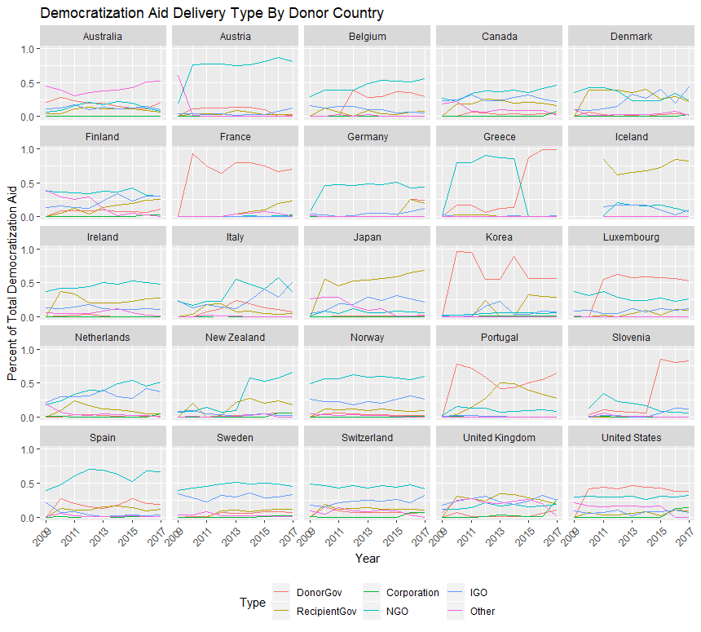

*Figure 1: The delivery methods favored by each of the OECD countries from 2009 to 2016 as a percent of each country’s total democratization aid disbursement. Some donor countries were omitted due to partially missing data.*

Figure 1 shows the aid types favored by 25 of the 36 OECD countries in our study. Some donors have adopted a preferred means of delivery aid, like France, which almost exclusively delivers aid itself, or Germany which relies exclusively on NGOs and IGOs. However, other countries have been actively trying different ways of delivering aid over the last decade, suggesting that no one method has proved best at achieving democratization goals. The United Kingdom, which was mentioned in the opening vignette, is a good example of a country with no one type and uses all means of delivery except for implementing the aid itself.

While corporations have always made up a much smaller portion of international aid delivery mechanisms, they have been increasing in popularity. In 2017, Estonia and the United States delivered almost 15% of their democratization aid via corporations and the United Kingdom delivered over a quarter of its aid that way. A number of other countries, including Canada, France and Switzerland, used corporations for the first time in the last two years to deliver democratization aid. Figure 2 shows the 2017 totals of democratization aid by delivery type for the twelve largest OECD donors. While it is unclear where this trend will go in the next decade, a better understanding today of how corporations delivering aid impacts the desired outcome is critical for foreign aid research.

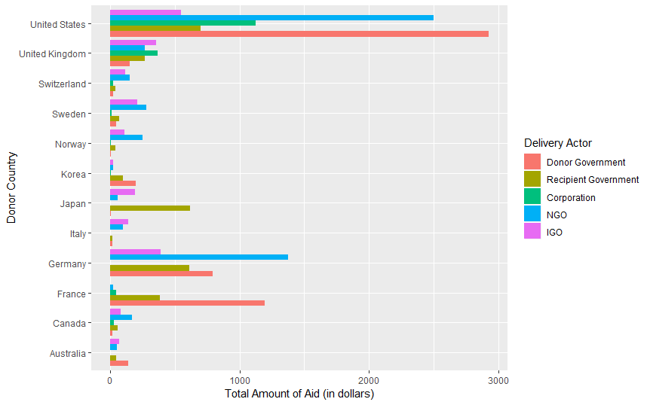

*Figure 2: Total Amounts of Democratization Aid in 2017 by Delivery Actor Type for the 12 Largest OECD Donors*

*Existing Literature*

Scholars have a variety of conflicting perspectives on aid’s relationship with democratization, partly because they measure aid somewhat differently from one another. This means that when they find an effect on democracy, it is through differing causal mechanisms and different ideas of what aid is and what types of aid matter. We begin by first reviewing literature on the relationship between general aid and democracy broadly, followed by a review of literature focused on aid specifically directed toward democratization. We then provide a short review of the literature on the motivations of donor state choices.

Scholars that focus on all types of international aid have found positive, negative, and null effects on the resulting amounts of democratization. Findings of no effect may be due to aid replacing tax flows, therefore decreasing accountability to a population, when money comes from donors.[5] On the other hand, a variety of authors find that overall aid packages inhibit democratization. These depend on various mechanisms. First, the size of the winning coalition and selectorate may be crucial. De Mesquita and Smith argue that leaders want to stay in office and will make very small policy/democratization concessions that are not politically costly for aid money when they have a small coalition and a large selectorate.[6] According to this research, aid money does not increase democracy, but is used as a political tool to keep leaders in office. Others argue that there is no effect because aid holds a similar “curse” effect to oil in developing countries.[7] Remmer argues that aid incentivizes target government spending but decreases revenue generation. She argues that this market-oriented aid is bad for capacity-building in developing countries.[8]

On the other hand, some authors find that democratization is increased with general aid. Gibson et al. find that post-Cold War aid increased the use of technical assistance and specific programs rather than budget support, preventing leaders in developing countries in Africa from diverting it through patronage networks.[9] New democracies that receive a large influx of aid immediately upon transition are more likely to experience democratization.[10] Sarah Blodgett Bermeo finds that aid from OECD countries increases the probability of a transition to democracy.[11]

Joseph Wright looks specifically at authoritarian regimes and finds that aid can have a positive influence when dictators have a large distributional coalition, but can help them stay in power when they have a small distributional coalition.[12] Dunning finds that in the post-Cold War era, conditionality of aid and threats to rescind it allow aid to be a positive influence on democratization.[13] Bermeo finds a similar result to Dunning; the negative effect of aid on democratization is only applicable to the Cold-War period. Post-cold war, aid has mixed results, including positive ones.[14] During this period, aid aimed at economic growth can increase democratization outcomes in the short term[15] and increase the likelihood of a successful transition to democracy. [16]

Much of this work groups all types of aid together and often assume that it operates only as budget support, going directly from donor state to target state’s budget. This is incorrect, as most aid is given for a specific purpose and often towards particular sectors or programs. Democratization research that fails to distinguish types of aid ends up including many other types of aid that should not theoretically be strongly linked to changes in democratization. Because of this, we now turn to more specific work on aid that is directed to democratization.

Scott and Steele look at American democratization aid from 1988-2001 and conclude through quantitative models that targeted aid can have a positive effect. They note, “even when controlling for the parallel or simultaneous impact of democratization on aid allocations, carefully tailored democracy assistance packages can positively affect democratization independent of factors that influence the decision to provide aid”.[17] For them, the return on investment in terms of democratization is much higher for specifically targeted democratization aid than other forms of aid as a whole. We expand on this research by considering other donor countries in addition to the United States as well as by disaggregating different types of delivery actors.

Finkel et al. found similar results looking at democratization aid from 1990-2003. They argue that democratization aid does in fact have a positive effect on democratization through supporting the agency of actors in democracy - the education and empowerment of voters, support of civil society groups, and “constituencies of reform”.[18] We take particular interest in how this happens, as that is left unanswered, by focusing on the partners that deliver democratization aid.

Beyond the relationship between different forms of aid and democracy, literature on the drivers of donor choice is key to setting up our theory. Aid is administered by a large number of actors that are often ignored in the literature, and these different types of actors in the aid industry have grown and changed since the end of the Cold War. Many acknowledge a relationship between democratization aid, types of delivery actors, and democratization outcomes. They work with similar independent and dependent variables as we do (delivery actors and democratization outcomes, respectively), but they do not take into consideration the likelihood that aid will actually be used as it is intended.

Some note that since the end of the Cold War, donor goals have shifted to focus on democracy promotion as a very important area of aid, especially in terms of good governance and government capacity, as well as the skyrocketing of democracy assistance since the late 1980s.[19] The use of multiple delivery actors is evident in Gibson et al.’s assessment of the move to technical assistance, an important distinction in the type of aid (as opposed to budget support) that allowed for more donor oversight.[20] They indicate that funds delivered to a project or an NGO are likely to have different effects than budget assistance, though they do not set up hypotheses or an argument that is testable, nor is it a focus of their research.[21] This change in aid represents both a move to technical assistance, increased oversight, and provision of such assistance through channels that are not directly donor to target.

With regards to outsourcing to intervening actors between donor and target, Simone Dietrich examines factors that affect donors’ aid choices. While we examine the *effects of the donor choices*, her focus on these donor choices as a dependent variable matters significantly. She explicitly notes that of OECD aid, over 30% is redirected through different channels, including multilateral, NGO, or private actors, as opposed to directly from government to government.[22] This is especially true for smaller donor states. She labels this “bypassing” and makes the case that this is because of both donor state attitudes on the role of the government in providing services (i.e. social democracies vs. more neoliberal states), and donor perception of good governance in the target state.[23] This use of bypassing because of donor attitudes is in addition to the fact that some donors are likely to outsource to other delivery channels if they perceive bad governance, and others may add extra controls or oversight to combat governance by ensuring that aid is not fungible. [24]This is a really important argument for understanding why and how states make the decisions they do surrounding delivery of aid, but it does not focus particularly on democratization aid. Her focus on the variation in delivery channels within OECD states is novel compared to other studies, especially in connection to good governance, but the connection to specific categories of aid and questions of democracy with respect to good governance are not covered.[25]

In other work, Dietrich notes that aid that goes through other delivery channels is particularly effective for supporting “opposition parties, watchdog media, and civil society organizations that might effectively demand more accountability and that, evidence suggests, ultimately strengthens democracy”.[26] This means that there is very good reason to study democratization and alternative delivery channels, which our paper does, by examining in particular the effects of aid specifically targeted to democracy that goes through these alternative delivery channels. From a broader perspective, Findley et al. examine donor choices, as well as whether target governments are able to use aid for their own purposes (elite capture of public revenues). Ultimately, by comparing elite opinions on aid, public opinion on aid, and donor behaviour, they assess varying levels of control of the aid allocation process and elite capture of public revenue.[27] They do not focus on democratization aid, but they focus on how donor choices are related to good governance.

Lastly, Sarah Sunn Bush notes that democratization aid is money that aims to promote democracy such as “advancing human rights… teach civics, support civil society groups, train the media, and encourage women to run for political office”.[28] She categorizes it as a form of democracy promotion that is a separate tool from other carrot or stick attempts to push democracy. Bush’s work provides significant insight into how democracy assistance works within organizations and on the ground. She argues democracy assistance delivered by NGOs has been “tamed” since its beginnings in the 1980s[29], making it less “confrontational” to particularly authoritarian regimes. She notes that this does not mean “bad” or ineffective, but less aggressive in their pushback against authoritarianism because of the pressures to continue receiving donor-government funding and to continue to having access to target states. Using a transnational case-study approach and organizational explanation that looks at primarily authoritarian regimes, she sketches out the challenges that NGOs face. Ultimately, her conclusion that the complex relationships between donors, targets, and NGOs can affect the way that democracy assistance is provided, causing a shift from the 1980s to the present. Bush’s explanation of watered-down assistance explains many of the constraints on NGOs that we consider important and take into our account in our hypotheses, though it does not convince us of a case that NGOs are not capable of providing some effectiveness at improving democracy more broadly in non-fully authoritarian regimes (especially in light of Dietrich’s findings). This is notable particularly in terms of a wide and diverse measurement of democratization, as seen in indicators such as V-Dem, which we use.[30]

Further, Bush’s discussion of the constraints that NGOs face is extremely valuable because she explains a more micro-context than we examine, which helps us in the interpretation of our results. While we look at a broader range of regime types across all OECD-designated target countries, it is important to zoom in to understand power relations on the ground in both hypothesis design and interpretation of results. For example, as we later explain, we find positive, significant results for the effectiveness of NGOs at improving democracy. This does not contradict Bush’s work, rather it helps us understand that despite these overall positive results, the results specifically in authoritarian regimes are probably much lower than in other regime types. Our work puts some of these arguments about NGOs in comparative perspective with other delivery actors

*Theory*

A challenge in navigating the vast literature on aid and democratization is variation in ways of defining aid. In building our theory, we follow Resnick and van de Walle, as well as Dietrich and Wright, who make the case for being clear about definitions. For democratization aid specifically, we use the following definition: “technical and material assistance to governments that are trying to consolidate democracy, as well as to nongovernmental groups that seek to monitor public institutions and processes, promote human rights and access to information, and encourage democratic participation”.[31] This is also nearly identical to and compatible with Bush’s definition. In our case, the “technical and material assistance” being examined is the financial flows that fund that technical and material assistance; our data represents the financial amounts behind that.

This specific definition of democratization aid fits into the OECD’s general definition of aid, which they refer to as Official Development Assistance (ODA). We select the OECD’s definition of aid because it is consistent with the data we use, which represents the financial flows of this aid. By finding the intersection of this definition and that of democratization aid in the literature, we are able to isolate the exact type of aid for which we select quantitative data. ODA is a particularly important definition, because it is what is regulated by the OECD (and the “gold standard” of aid since 1969) and is also enshrined in legislation or budget rules for aid in nearly all OECD countries. It is defined as “resource flows to countries and territories on the DAC List of ODA Recipients [defined as developing countries] and to multilateral development institutions that are i) provided by official agencies….ii) concessional and administered with the promotion of the economic development and welfare of developing countries as the main objective”.[32]

Military aid and security promotion as well as aid with primarily commercial objectives are NOT considered ODA and so this separates out major peacebuilding and security sector reform initiatives.[33] Democratization aid as defined above represents a subset of ODA, as defined here. This clear definition of ODA and our clear definition of democratization aid (applied to the aid that is also ODA) give us a small focus area for which we test the effects of democratization aid on democracy outcomes. For example, there is a significant literature on foreign intervention, peacebuilding, and democratization, but ODA is exclusive of military activity and larger scale intervention, so our scope is separate from that literature and those questions. Further, there is a literature on the role of international organizations and their effect on democratization or peace, but it is less relevant here because it does not apply to their donor policies, but rather broader effects such as credibility of commitments to global audiences in the process of democratization.[34]

With these definitions in mind, we turn to a key mechanism on which we build our theory: fungibility. Fungibility refers to whether the aid in question is used for its intended purpose or whether it becomes interchangeable with other money and is used for different purposes. Our main argument concerns the fungibility of the way democratization aid is delivered; in other words, we focus on whether aid is used for its intended purpose or not. If aid is fungible, we believe it will be less effective at improving democracy. Different actors delivering aid can have variation in the level of fungibility. Kassandra Birchler, Sophia Limpach, and Katharina Michaelowa argue that more fungible aid has a negative effect on democratization, as it allows actors to use it for unintended purposes, such as those that entrench non-democratic practices. Similarly, aid less fungible can be good for democratization, as it strengthens accountability because it cannot be used for other purposes.[35] We build on this very important argument about fungibility and ask *how* a delivery actor affects aid’s impact on democratization, Birchler et al. are not the only ones to look at fungibility,[36] but they do it especially well in terms of assessing fungibility based on type of aid modality.

Instead of studying World Bank and IMF loans like Birchler et al., our project looks at donor countries and the delivery actors with whom they partner, as demonstrated in Figure 1. This also frames our project differently, as loans create a different relationship between donor and target since they must be paid back. We look at aid rather than loans, looking specifically at democratization aid in this project. As stated above, our primary argument is that type of delivery actor impacts democratization outcomes depending on how fungible the democratization aid in question is.

We borrow Birchler et al.’s understanding of fungibility as a causal mechanism, building on their argument by incorporating the delivery actors of democratization-focused aid into our analysis. In our argument, fungibility is not just about the donor-target relationship. Variation exists depending on the actor who ultimately delivers the aid (local government, private sector organization, non-governmental organization, multilateral organization/Intergovernmental Organization) because fungibility is important from their perspective. This is similar to Sarah Sunn Bush’s argument about NGOs being constrained by their own need to survive in the context of both donor and target states.[37] Some delivery actors will allow for more fungibility of aid than others, and with more fungibility, democratization will decrease. With less fungibility, democratization will increase. It is on this principle of fungibility and delivery actor that we build our hypotheses.

Our theoretical contribution is a thus comparative analysis of different types of actors and the variation in fungibility between them. Our dependent variable is democratization, an effect of democratization aid, and the related independent variable we care about is the donor decision to deliver the aid through partners (delivery actors). Bermeo argues that donor countries pay attention to governance and tailor their aid around those concerns, such as those concerning different ability and/or willingness of a target government to use aid for purposes other than development.[38] While not specifically focused on democratization aid, her focus on good governance and how aid money is used is important because it is consistent with the concept of fungibility introduced by Birchler et al., which is a cornerstone of our theory.

We also use the most recent and comprehensive data available. In 2004, the OECD began collecting data on how each country delivered aid, information that was unavailable to earlier scholars. Our project looks at this more current data and is able to disaggregate democratization aid by delivery actor in order to look deeper at the trends and hypothesize an important causal mechanism. Further, the quality of OECD data has improved in recent years, allowing us to provide a large N study, something that Finkel et al. note is incredibly important and was previously lacking due to poor quality of data.[39]

*Hypotheses*

With this in mind, our hypotheses are as follows:

*1. Democratization aid from donor countries that is delivered by local governments and private sector actors is the most fungible and therefore the least likely to lead to an increase in democratization.*

*2. Democratization aid from donor countries that is delivered by NGOs or multilateral organizations (IGOs) is the least fungible and more likely to lead to an increase in democratization.*

We expect these outcomes because, as partners, NGOs and IGO organizations have a significant amount of accountability and transparency to donor countries. Further, they rely on donor countries for their survival (outside of specific projects, they require donor money for paying staff, etc.) and so they will want better outcomes and to be more transparent, even if it limits their scope of work and shapes their professional environments. Further, they are more non-partisan than other organizations and so they may be better placed to effectively support independent media, get-out-the vote campaigns, opposition parties, election monitoring, and freedom of information.[40] Therefore, NGO and IGO-delivered aid is less fungible and more likely to facilitate better democratization.

Private sector actors do not rely on donor countries for their survival and in some cases are not accountable to donor countries for their actions abroad. They may be trying to undertake development work, but their desire for profit will be prioritized and partnerships with local governments may trump their partnerships with donor governments because it will also increase profit. Local governments, as partners, will experience some of the negative effects demonstrated by authors who find mixed and negative results of aid on democratization, as this resembles budget support and these governments have more incentives to make aid fungible if it helps entrench existing leadership.

To be clear, we expect the effect of even NGO work and IGOs to be quite small, given the precedent of results set in earlier work, but we hypothesize with more optimism that it may contribute to better outcomes comparatively because of fungibility. In particular, some scholars have specifically focused on the effects of one type of delivery (i.e. NGOs alone as Bush does) or another, but the cross-delivery comparison that we do is in an effort to link these different ideas.

*Research Design & Data*

In order to test these hypotheses, we compare the effect of different aid delivery mechanisms on various measurements of democracy. While Knack and others point out that disaggregated data was lacking at his time of writing (2004),[41] data has become much more available and more information about projects has been collected since 2004, including the delivery channel as an important aspect of a project. Improved ODA regulation in donor countries, improved OECD standards, and improved UN data collection and reporting contributed to this.

The goal of this analysis is to test whether aid delivered via NGOs and multilateral organizations is significantly better at improving democracy than aid through governments and corporations. We do this with a two-part research design. First, we regress the aid totals for each delivery method as well as some standard controls regularly used in democratization research against a suite of indicators for democracy. We then test for a significant difference between the coefficients for the modes of delivery and correct the p-values for the multiple comparisons undertaken.

To get aid totals by delivery method, we took the OECD’s official ODA data from their Creditor Reporting System (CRS) and selected out all transfers that could be considered democratization aid. ODA does not provide a specific set of codes for democratization aid, but most of the aid is clearly marked by its intended purpose. Of the 257,431 projects reported in 2017, only 686 were given a higher level, 3-digit code relevant to an entire category (such as “Health” or “Government and Civil Society”) as opposed to much more specific 5-digit code corresponding to the specific goal the project was oriented towards. We used these specific codes to select the projects with stated purposes that were most in line with democratization aid we want to test in this analysis.[42]

One of the mandates of the OECD’s Development Assistance Committee is collecting statistics and it has built a very sophisticated architecture for data and information. Looking at the structure of all OECD data sets, they have a category for governance and civil society, representing all aid *intended* for the purpose of improvement of those. We then split the data into six different groupings based on method of delivery: donor government, target government, NGO, IGO (multilateral organization), corporation, and other. The other category is the result of observations in the original dataset themselves called other. While the category itself is not of substantive interest, it is necessary to include because we need to control for all democratization aid given to a country in a given year. All aid totals are logged.

The resulting OECD dyad-year data spans the thirteen-year period from 2004 to 2017. It includes all aid between 32 of the 36 OECD countries to 126 other countries. Mexico, Turkey, and Israel are excluded because although they show up in the larger CRS data, they never give democratization aid. Chile is excluded from the CRS data altogether. Aid from non-OECD countries is not included in the data. A few of the other countries are missing data from the 2004 to 2008 time period. Systematically excluding these countries would be a problem if the effectiveness of the method of delivery differed between this group and the OECD countries. Even if we did have this data, that argument would be difficult to test because non-OECD countries give almost no aid for democratization purposes. Nevertheless, we remove aid from non-OECD countries from the scope of this analysis and restrict our conclusions accordingly.

The lack of randomness in how countries choose their delivery channel is a constraint of the research design. Donor countries may take into account a range of factors when deciding whether to deliver aid projects themselves or outsource it to another actor, including whether they have infrastructure already in the country, what relationship they already have with other delivery actors, and their own domestic politics. With the exception of pre-existing investments and activity within the recipient country, most of these issues should impact all the recipients of aid from the same donor the same.

The dependent variable for this project is the amount of democracy in a country the year after aid is given. Among the numerous measurements of democracy, we utilize three indicators from the Varieties of Democracy Project (V-Dem) as well as the commonly used Polity IV measure. V-Dem’s benefit is that it separates the measure of democracy into five high-level indicators--electoral, liberal, participatory, deliberative, and egalitarian--of which we use the first three. These indicators are themselves built off hundreds of low-level indicators with the goal of reflecting specific qualities of democracy rather than democracy as a whole. They are much more fine grained that Polity or Freedom House with near continuous measurements on the interval from 0 to 1. While deliberative and egalitarian measurements of democracy are important, these are not typically the targets of democratization aid and thus not the best measure of its effectiveness. However, we do present results for these measures in Appendix C1. Electoral, liberal, and participatory outcomes are all highly correlated with one another above .9, but the variation is useful because as we show in our results the codings can result in slightly different outcomes. Polity has the benefit of being widely used and recognized by scholars in many areas of research, so we include it as well in our main analyses. Each of these dependent variables is standardized to allow for some comparability between models. Freedom House measures are not reported here, but are available in Appendix C2.

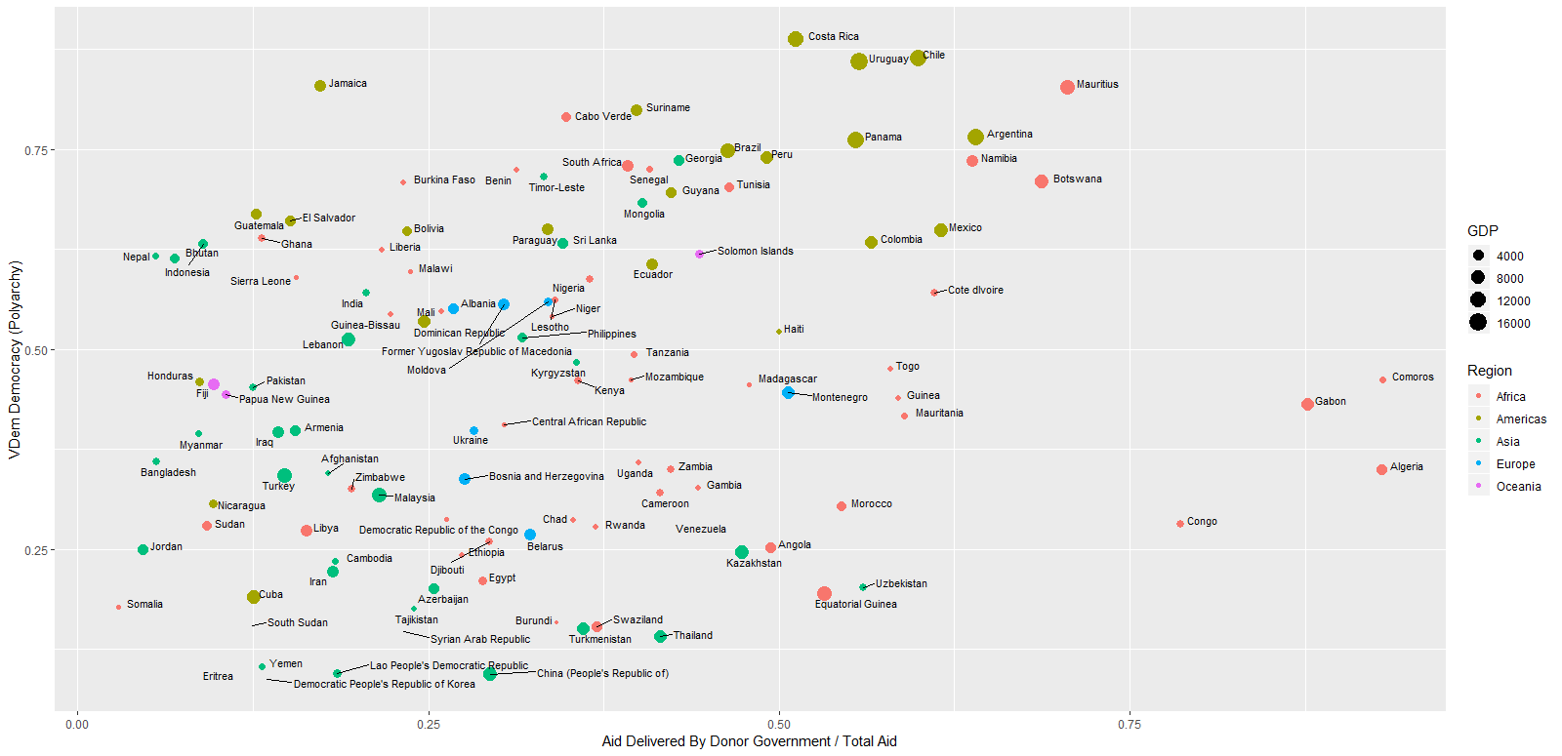

*Figure 3: Percentage of Aid from Donor Governments on 2017 V-Dem Polyarchy Scores*

Figure 3 visualizes some of this data by looking at the relationship between the percentage of aid that is delivered directly by donor governments versus the recipient country’s V-Dem score for the polyarchy indicator. With some notable outliers in Africa that get the majority of their aid delivered directly by the donors despite having relatively weak democracy scores, there appears to be a weak relationship between the two variables.

In addition to the ‘other’ category of aid delivery, which allows us to control of the total amount of aid given in each dyad, we include controls for the percent of the country that is urban, logged population, and logged GDP per capita. These measures come from the World Bank and are widely used in this type of literature.[43] We run fixed effects by country level, but these are important controls that may encourage democracy over time within a country. We also control for the percentage of a donor’s GDP that is involved with foreign direct investment (FDI) to approximate for how globalized their economy is. This is useful for controlling for the economic incentives regarding how a country might choose to deliver its international aid. We also control for the amount of FDI a recipient country receives as a portion of their GDP to approximate how each recipient engages with international trade. It helps to approximate differences in how a recipient country might allow foreign actors access to their domestic economy. While these are not perfect measurements about how each donor and recipient country might respectively choose to deliver their aid or put restrictions on how they receive it, but they are a good option given that such a measure would be near impossible.

We also add the appropriate lagged democracy score (lagged electoral for the electoral model, lagged Polity for the Polity model, etc.) to help address autoregressive properties of the time-series data. In most cases, the best predictor of democracy in a given time period will be the amount of democracy in the preceding time period.

Each of the models run is a fixed effects model clustering on dyads. This method has the benefit of stripping out factors that might differ between donor countries, as well as between target countries. However, it is possible that donors coordinate, meaning that dyads with the same target country are incredibly similar and only serve to increase the number of observations. We check for this with a robustness check in Appendix C5 that aggregates aid and runs fixed effects by target instead of dyad. The results are similar, but suggest that IGOs have a more statistically significant impact on democracy than NGOs. This difference makes logical sense as use of NGOs is likely to differ by donor while IGOs are more likely to be used by groups of countries in coordination. For example, all European countries may give aid through the European Union but only some of them will also do so through Oxfam. These additional results support our earlier criticism of analytics on international aid. While the unit of analysis is a theoretical concern, the empirical results can differ substantially. If the question were about an individual country’s choice of aid channel, then pooling on the target would be inaccurate. Such an analysis would be more warranted if the question were what type of aid all donor countries should choose together, such an analysis would be more warranted.

*Results*

The results of the four models are shown in Figure 4 with 95% confidence bands around the point estimate. The dependent variables are all standardized, ranging from about -2 to 2 with a mean of 0. This slightly changes the interpretation of the coefficients as the effect on the spread of values the DV can take and reduces the role of outliers in the dependent variable, but it makes it much easier to compare values. Since measurements of democracy are unitless approximations of a difficult to capture concept already, this manipulation should have little effect. The participatory V-Dem measure does have some outliers beyond 3. Full tables of model results are included in the Appendix, but because the difference between these coefficients is of interest and not the coefficients themselves, they are not presented here in detail. It is important to notice that not all types of democratization aid significantly contribute to a country’s democracy. Across most models, aid delivered by governments, whether the donor or the target, result in statistically insignificant and near zero changes in democracy the following year. NGOs and IGOs are the only actors that consistently increase democracy across all four dependent variables. Both the electoral and participatory models are significant at the .5 level and in the liberal model at just beyond that threshold. Corporations stand out as having a significantly negative effect on the levels of democracy that they deliver aid to. This means that democratization aid sent through for-profit actors actually has the opposite effect from what the donor intended.

With the largest effects about .05 on a scale of -2 to 2, these are admittedly very small effect sizes, especially remembering that the aid totals are all logged. This is to be expected as we know that democracy within a country over time typically changes very slowly and that international aid is incapable of causing immediate or large changes. If we did see large effect sizes, it would be concerning and might suggest a potential endogeneity problem since intuitively we know that aid cannot be responsible for large changes on its own.

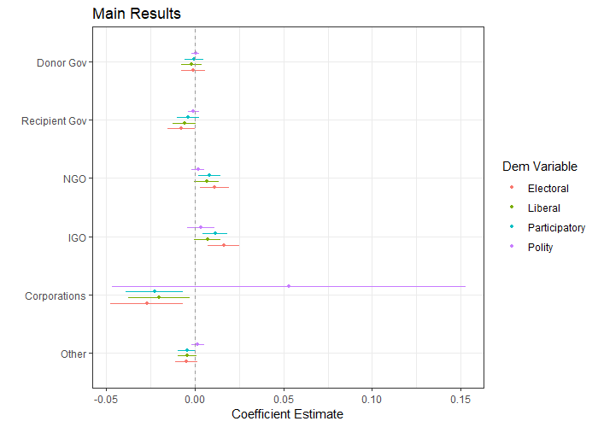

*Figure 4: Effects of Different Aid Delivery Mechanisms on Various Measures of Democracy*

These results also illustrate the importance of considering multiple measurements of democracy. There is relatively little difference between the various V-Dem estimates, but some of the coefficients vary quite a bit from the those arrived at through the Polity model and none of the estimates in the polity model are significantly different from zero. For our purpose, none of the measurements seem to be universally biased in one direction or the other, but considering multiple indicators helps address some of the nuance in studying the impacts of democratization aid.

While these regression results are interesting, to test our hypotheses we need to see whether NGOs and IGOs are significantly better than governments and corporations. To do this, we test whether the coefficients are equal using a 𝜒2 test. In Figure 5, we present the p-values of interest graphically but the full tables of tests are available in Appendices C7. The vertical bar drawn at .05 represents that traditional cut off for statistical significance. The first plot in the figure includes the p-values for all of the possible comparisons; however, this raises the issue of multiple comparisons. Making multiple comparisons between related groups increases the probability of finding significant results. The second plot controls for this family-wise error rate by using Holm-Bonferroni adjusted p-values, but the modification is often considered highly restrictive and can be more conservative than necessary.[44] For this reason, we present both the raw and adjusted p-values.

In both the adjusted and raw results, NGOs and IGOs are significantly better at achieving democratization outcomes in almost all of the electoral and participatory V-Dem models with the exception being that NGOs are just barely indistinguishable from Donor governments at the p < .05 level of statistical significance. In the liberal V-Dem model, NGOs and IGOs are also better than corporations but not necessarily better than government actors. This is partially driven by the weaker ability of NGOs and IGOs to deliver this type of outcome, which can be seen in both panels of figure 3.

In multiple models, corporations are significantly worse at delivering democratization outcomes than NGOs and IGOs, but they are not significantly different from donor and recipient governments as aid delivery actors. This is due, at least in part, to their rarity in the dataset. Less than 300 of the over 15,000 dyad-year observations had international aid delivered by private corporations. However, this mode of delivery is gaining in popularity. The United States used corporations in 2016 and 2017 to send aid to over 80 different countries. Switzerland used them in 20 cases and Sweden used them in 10. Although they are not a large part of democratization aid currently and we don’t have the data to make strong conclusions regarding their efficiency relative to other delivery methods, future research should be careful to select out the unique actor.

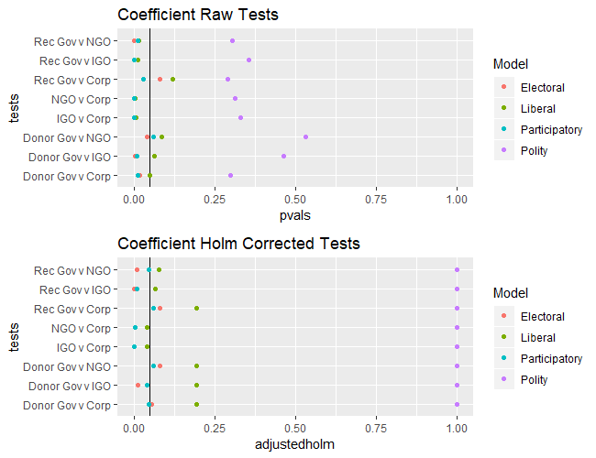

*Figure 4: Raw and Holm Corrected p-values for the Difference between Methods of Aid Delivery*

These results would also be possible if different delivery actors were chosen for different amounts of current democratization. There is no perfect test for solving this endogeneity problem, but we can point to three tests that support our hypotheses. First, our models already look at the democracy in a country the year after the aid was disbursed. Second, we include the appropriate lagged dependent variables in an attempt to control for previous amounts of democratization. Finally, we also present the results of an error corrected model for the polity dependent variable in the appendix. This model uses lags and differences to see how correlated the dependent variable is with chosen independent variables. This model cautions there may be some endogeneity present with the NGO and IGO totals.

*Conclusion*

Inside the black box that is ‘aid’, there are a significant number of differing flows of money that many scholars have failed to acknowledge. The ways in which this aid flows are important for understanding how international actors can play a prominent role in the domestic politics of developing countries. This is particularly salient when the effect is on democratization in these countries. While scholars have found very mixed results on the effects of aid on democratization, this is often because they have had poor data, unclear definitions of aid, and poor understanding of causal mechanisms. We have provided a comprehensive study that links arguments about democratization aid and democratization outcomes with a distinct argument about different types of actors that deliver aid and their accountability relationship with donor states.

We have argued in this paper that the delivery actors of international democratization aid matter. We have broken down delivery actors into four categories – private sector, NGO, local government, and multilateral IGOs– and have argued that specifically for democratization aid, actors have varying levels of fungibility in their work that lead to variation in outcomes for democracy.

We have shown using data from over ten years of aid delivery from OECD to developing countries that NGOs and IGOs are consistently better at achieving democratization outcomes with the aid that they deliver. Not only are they the only actors that have a statistically significant and positive impact on aid, they are also significantly different from the other types of actors, especially when a broader coding of aid is considered. A key follow up question to pursue would link our comparative results to Bush’s work on the constraints that NGOs face in delivering democratization aid. This follow up question could be: Is there variation in the effectiveness of NGO-delivered democratization aid between local, civil society-driven NGOs and large, transnational NGOs? If so, is this because of fungibility or because of other reasons?

Although the effect we have found is indeed small, this does not mean that it is unimportant, as democratization is a complex, multicausal, and contested process, and so it is expected that the effects of international aid are simply supportive to the process. By focusing on a specific definition of democratization aid and reflecting that in our data set, we have built on the literature on democracy, international aid organizations and partnerships, and fungibility.

This has particular policy relevance in 2018 as well as a contribution to the aid effectiveness literature in international development. The outsourcing and partnership models of aid have increased significantly since the 1980s[45]and especially in the 21st century. It is even more widespread than most international relations scholars acknowledge and is continuing on this path. For example, the U.S. State Department’s 2019 budget request reduces funding for the National Endowment for Democracy and removes internal agencies, instead relying on external contractors to deliver the democratization aid that remains. While the National Endowment for Democracy has been a controversial and justifiably-criticized actor associated with American-imposed regime change and interventionism, we strongly suggest attention to be paid to the many types of alternative actors that may replace it.[46] A key question for policymakers and practitioners across all four delivery groups is about whether their aid “works” or makes a difference. Further, they are interested in value for money; in other words, whether they are seeing positive results relative to their investment. This is part of a broader aid effectiveness agenda within the governing organizations of international development, including the UN and the OECD. It is very possible for donors and their partners to be ineffective, from a variety of perspectives, and so there is considerable emphasis from these organizations and their regulatory bodies on monitoring, evaluation, audit, efficient delivery, and production of good results. This reflects what Bermeo calls the shift towards “targeted development” and also reflects many of the commitments towards results and effectiveness in major agreements such as the Sustainable Development Goals. The increased focus on the aid effectiveness agenda in the realm of policy and practice demonstrates a need for further comprehensive study in academia not just on whether aid “works”, but on the causal mechanisms of how and why.

We recognize that progress towards democracy is messy and fraught, and it is a difficult path on which indices cannot fully capture the complexity. Current Western democracies forged long and violent paths to achieve their democracies and have established standards of democracy based on these experiences. As it stands, their democracies are facing major challenges in 2019. We acknowledge that democratization is a complex and messy process. As a result, the role of Official Development Assistance in that process is small. We found that some large amounts of aid have a small positive impact on annual ratings of democracy in recipient countries. Regardless, democratization aid is still a major effort by OECD countries and it is important to understand whether or not it is beneficial and the effects that donor choices have on target countries. For example, according to Canada’s international assistance project browser, general governance and civil society projects that are currently operational and terminating, (the majority of which overlap with our conception of democratization aid and are represented in our data), represents a portfolio of $4,819,866,016, distributed through a variety of delivery actors.[47] Even if the resulting change is democracy is small, it is important to understand which delivery actors will implement this aid most effectively.

Lastly, there are important conclusions of our work for broader areas of international relations. While our contribution is a quantitative study of effectiveness broadly, it provides a theory of how aid and democracy interact that is relevant to critical scholars of international relations and development. These scholars are calling into question and investigating the assumptions and political motivations of aid policy, as well as the political and normative implications of it. With results that demonstrate a causal process of democratization aid effectiveness, critical scholars have new material with which to examine the political and normative implications of this process, as well as the assumptions, forms of knowledge and power, and constitutive origins of the aid partnership models more broadly. We take seriously the concerns of many scholars that the aid system is broken and ineffective, particularly in terms of exporting liberal democracy, and we also take seriously the concerns that democratization aid more broadly is an attempt to impose values and systems without consideration for local knowledge, existing systems, or colonial history. Our paper does not make a normative judgment on democratization aid directly, but it serves to demonstrate variation in the effects of the money put towards democratization aid and provides a contribution of use to both normative and non-normative scholars alike.

**Bibliography**

Aickin, M, and H Gensler. 1996. Adjusting for multiple testing when reporting research results: the Bonferroni vs Holm methods. *American Journal of Public Health* 86 (5): 726–728.

Bader, Julia, and Jörg Faust. 2014. Foreign Aid, Democratization, and Autocratic Survival. *International Studies Review* 16 (4): 575–595.

Bermeo, Sarah Blodgett. 2017. Aid Allocation and Targeted Development in an Increasingly Connected World. *International Organization* 71 (04): 735–766.

Bermeo, Sarah Blodgett. 2016. Aid Is Not Oil: Donor Utility, Heterogeneous Aid, and the Aid-Democratization Relationship. *International Organization* 70 (01): 1–32.

Bermeo, Sarah Blodgett. 2011. Foreign Aid and Regime Change: A Role for Donor Intent. *World Development* 39 (11): 2021–2031.

Birchler, Kassandra, Sophia Limpach, and Katharina Michaelowa. 2016. Aid Modalities Matter: The Impact of Different World Bank and IMF Programs on Democratization in Developing Countries. *International Studies Quarterly* 60 (3): 427–439.

Bush, Sarah Sunn. 2016. *The taming of democracy assistance: why democracy promotion does not confront dictators*. Cambridge, UK: Cambridge University Press.

Carnegie, Allison, and Nikolay Marinov. 2017. Foreign Aid, Human Rights, and Democracy Promotion: Evidence from a Natural Experiment. *American Journal of Political Science* 61 (3): 671–683.

Danish, Jamil. 2016. Afghanistan’s corruption epidemic is wasting billions in aid. *The Guardian*, sec. Working in development. Available at <https://www.theguardian.com/global-development-professionals-network/2016/nov/03/afghanistans-corruption-epidemic-is-wasting-billions-in-aid>. Accessed 30 September 2018.

Dietrich, Simone. 2013. Bypass or Engage? Explaining Donor Delivery Tactics in Foreign Aid Allocation*: *Bypass or Engage?* *International Studies Quarterly* 57 (4): 698–712.

Dietrich, Simone. 2016. Donor Political Economies and the Pursuit of Aid Effectiveness. *International Organization* 70 (01): 65–102.

Dietrich, Simone, and Joseph Wright. 2015. Foreign Aid Allocation Tactics and Democratic Change in Africa. *The Journal of Politics* 77 (1): 216–234.

Djankov, Simeon, Jose G. Montalvo, and Marta Reynal-Querol. 2008. The curse of aid. *Journal of Economic Growth* 13 (3): 169–194.

Dunning, Thad. 2004. Conditioning the Effects of Aid: Cold War Politics, Donor Credibility, and Democracy in Africa. *International Organization* 58 (02): 409–423.

Findley, Michael G., Adam S. Harris, Helen V. Milner, and Daniel L. Nielson. 2017a. Who Controls Foreign Aid? Elite versus Public Perceptions of Donor Influence in Aid-Dependent Uganda. *International Organization* 71 (04): 633–663.

Findley, Michael G., Adam S. Harris, Helen V. Milner, and Daniel L. Nielson. 2017b. Who Controls Foreign Aid? Elite versus Public Perceptions of Donor Influence in Aid-Dependent Uganda. *International Organization* 71 (04): 633–663.

Finkel, Steven, Anibal Perez-Linan, and Mitchell A. Seligson. 2007. The Effects of U.S. Foreign Assistance on Democracy Building, 1990-2003. *World Politics* 59 (3): 404–440.

Gershman, Carl, and Michael Allen. 2006. The Assault on Democracy Assistance. *Journal of Democracy* 17 (2): 36–51.

Gibson, Clark C., Barak D. Hoffman, and Ryan S. Jablonski. 2015. Did Aid Promote Democracy in Africa? The Role of Technical Assistance in Africa’s Transitions. *World Development* 68: 323–335.

Gleditsch, Kristian Skrede, and Michael D. Ward. 2006. Diffusion and the International Context of Democratization. *International Organization* 60 (04). Available at <http://www.journals.cambridge.org/abstract_S0020818306060309>. Accessed 25 August 2018.

Hariri, Jacob Gerner. 2015. Foreign Aided: Why Democratization Brings Growth When Democracy Does Not. *British Journal of Political Science* 45 (01): 53–71.

Heiss, Andrew, and Judith Kelley. 2017. Between a Rock and a Hard Place: International NGOs and the Dual Pressures of Donors and Host Governments. *The Journal of Politics* 79 (2): 732–741.

Knack, Stephen. 2004. Does Foreign Aid Promote Democracy? *International Studies Quarterly* 48 (1): 251–266.

Levitsky, Steven, and Lucan Way. 2005. International Linkage and Democratization. *Journal of Democracy* 16 (3): 20–34.

Mansfield, Edward D., and Jon C. Pevehouse. 2008. Democratization and the Varieties of International Organizations. *Journal of Conflict Resolution* 52 (2): 269–294.

de Mesquita, Bruce Bueno, and Alastair Smith. 2007. Foreign Aid and Policy Concessions. *Journal of Conflict Resolution* 51 (2): 251–284.

Morrison, Kevin M. 2009. Oil, Nontax Revenue, and the Redistributional Foundations of Regime Stability. *International Organization* 63 (01): 107.

Pevehouse, Jon, and Bruce Russett. 2006. Democratic International Governmental Organizations Promote Peace. *International Organization* 60 (04). Available at <http://www.journals.cambridge.org/abstract_S0020818306060322>. Accessed 25 August 2018.

Remmer, Karen L. 2004. Does Foreign Aid Promote the Expansion of Government? *American Journal of Political Science* 48 (1): 77–92.

Rogin, Josh. 2018. The Trump administration wants to dismantle Ronald Reagan’s ‘infrastructure of democracy’. *The Washington Post*. Available at <https://www.washingtonpost.com/opinions/global-opinions/the-trump-administration-wants-to-dismantle-ronald-reagans-infrastructure-of-democracy/2018/03/04/8b94d7f6-1e54-11e8-ae5a-16e60e4605f3_story.html?utm_term=.1eaa5afda0a0>.

Scott, James M., and Carrie A. Steele. 2011. Sponsoring Democracy: The United States and Democracy Aid to the Developing World, 1988-20011: Sponsoring Democracy. *International Studies Quarterly* 55 (1): 47–69.

Strassburger, Klaus, and Frank Bretz. 2008. Compatible simultaneous lower confidence bounds for the Holm procedure and other Bonferroni-based closed tests. *Statistics in Medicine* 27 (24): 4914–4927.

Woods, Ngaire. 2006. *The Globalizers: the IMF, the World Bank, and their borrowers*. Ithaca, N.Y: Cornell University Press.

Wright, Joseph. 2009. How foreign aid can foster democratization in authoritarian regimes. *American journal of political science* 53 (3): 552–571.

2019. Search Project Browser. *Government of Canada*. Available at <https://w05.international.gc.ca/projectbrowser-banqueprojets/filter-filtre>. Accessed 28 April 2019.

2018. UPDATE 1-Donors halt aid to Zambian social welfare scheme over... *Reuters*. Available at <https://af.reuters.com/article/zambiaNews/idAFL8N1W46FF>. Accessed 30 September 2018.

2018. What is ODA? *OECD*. Available at <http://www.oecd.org/dac/stats/What-is-ODA.pdf>.

1. UPDATE 1-Donors halt aid to Zambian social welfare scheme over... 2018.
2. Danish 2016.
3. Findley et al. 2017a, 634.
4. Dietrich 2013; Dietrich 2016; Bermeo 2017.
5. Knack 2004, 251.
6. de Mesquita and Smith 2007, 251.
7. Djankov, Montalvo, and Reynal-Querol 2008, 169.
8. Remmer 2004, 77; For more on tax revenue, see also: Morrison 2009, 107.
9. Gibson, Hoffman, and Jablonski 2015, 323.
10. Hariri 2015, 53.
11. Bermeo 2011, 2023–2024.
12. Wright 2009, 555–556.
13. Dunning 2004, 409; For broader work on linkage and leverage in comparative politics, see: Levitsky and Way 2005; And for broader comparative politics arguments on international effects on democratization, see: Gleditsch and Ward 2006.
14. Bermeo 2016, 1.
15. Carnegie and Marinov 2017, 671.
16. Dietrich and Wright 2015, 232.
17. Scott and Steele 2011, 48.
18. Finkel, Perez-Linan, and Seligson 2007, 410.

    said that has stuck with me but may not need to go in riow does that affect fungibility" use of target vs recipient in both and
19. Dietrich and Wright 2015; Findley et al. 2017b; Bush 2016.
20. Gibson, Hoffman, and Jablonski 2015, 323.
21. Ibid., 324.
22. Dietrich 2013, 699.
23. Ibid., 701.
24. Ibid.
25. Findley et al. 2017a.
26. Quotation comes from: Ibid., 639; Summarizing: Dietrich and Wright 2015.
27. Findley et al. 2017a.
28. Bush 2016, 6.
29. Ibid., 22–24; Ngaire Woods notes that much aid was outsourced to NGOs as a method of moving services outside the state beginning under President Reagan in the United States. For more, see the concluding chapter of: Woods 2006.
30. Extensive methodological insights regarding ‘effectiveness’ are described by Heiss and Kelley: Heiss and Kelley 2017.
31. Gershman and Allen 2006, 36.
32. What is ODA? 2018.
33. Ibid.
34. Mansfield and Pevehouse 2008; Pevehouse and Russett 2006.
35. Birchler, Limpach, and Michaelowa 2016, 427.
36. See also: Bader and Faust 2014.
37. Bush 2016, 22–24.
38. Bermeo 2017, 749.
39. Finkel, Perez-Linan, and Seligson 2007.
40. See: Dietrich 2013.
41. Knack 2004, 262.
42. We originally created two codings for democratization aid. The first, a “narrow” coding, only includes 21 codes under the “Government and Civil Society” category that would clearly be intended to increase democracy in the country. The “broader” coding includes 76 codes across many categorizations of aid that would intuitively benefit democracy. A full list of codes is available in Appendix D1 and D2 respectively. While we only report the results of the broader coding her, the narrow coding is available in appendix !!.
43. For example: Birchler, Limpach, and Michaelowa 2016.
44. Strassburger and Bretz 2008; Aickin and Gensler 1996.
45. For a discussion of the neoliberalization of development and the earliest outsourcing partnerships with NGOs under the Reagan administration, see: Woods 2006.
46. Rogin 2018.
47. Search Project Browser 2019.